**Course categories menu:**

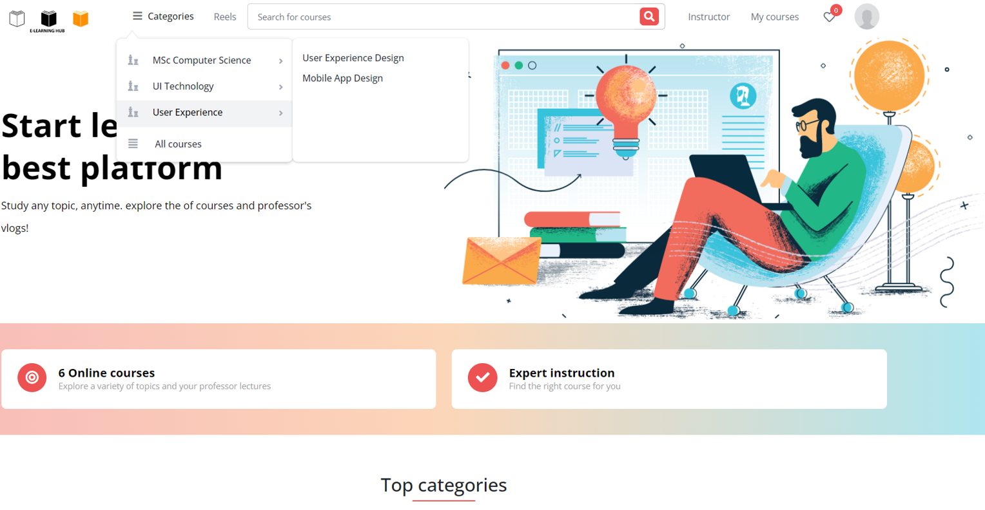

A course menu with a drop-down menu that comprises categories and subcategories may be found on the home page's left side. Kind of category and subtype Choose a particular category. can see all of the department's courses at once.

**Course Search bar:**

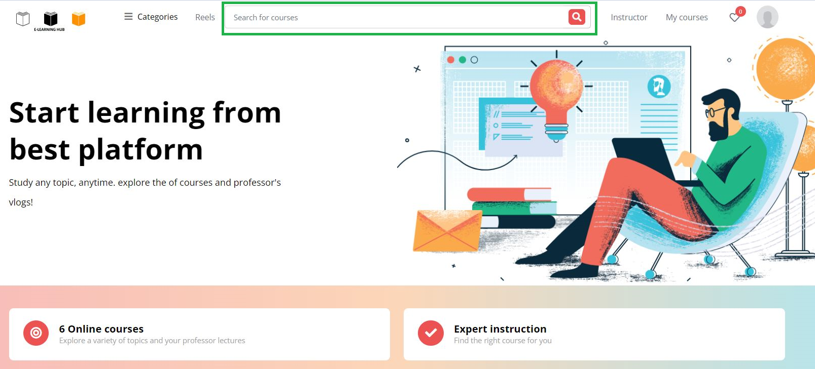

The search bar up top can be used by users to locate a course. User can find the necessary courses using the search bar.

**Course View:**

1. **Course List view**

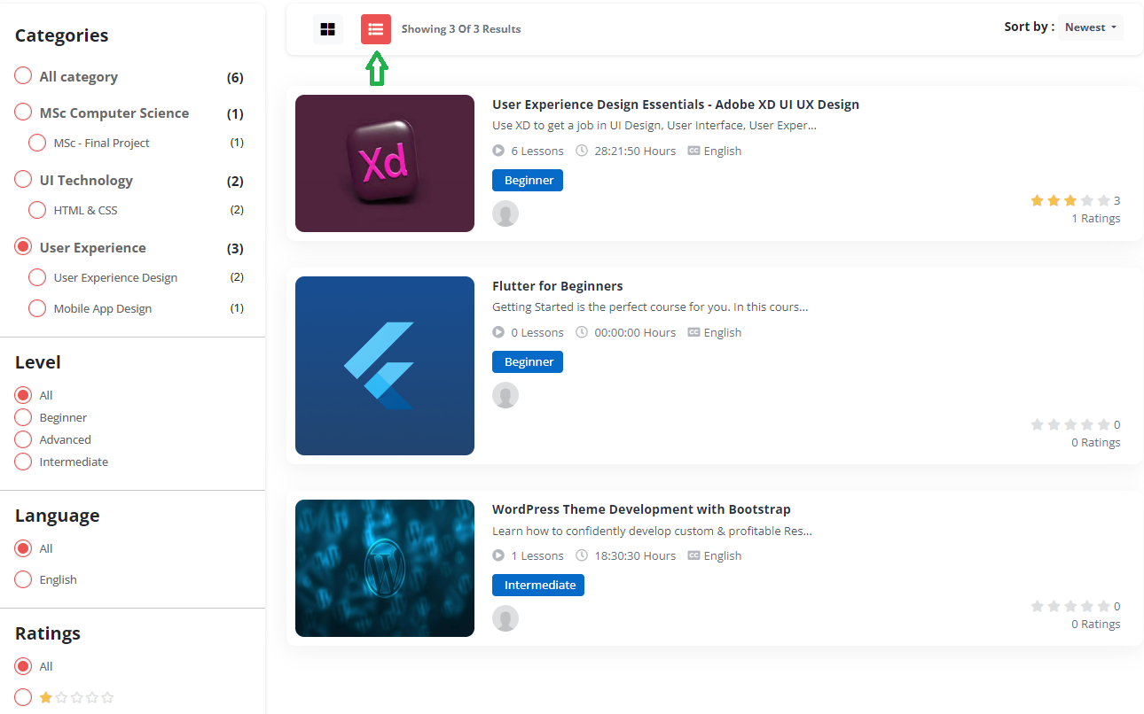

The user can utilise the list-icon at the top to view a list of all the courses on the course page.

1. **Course grid view**

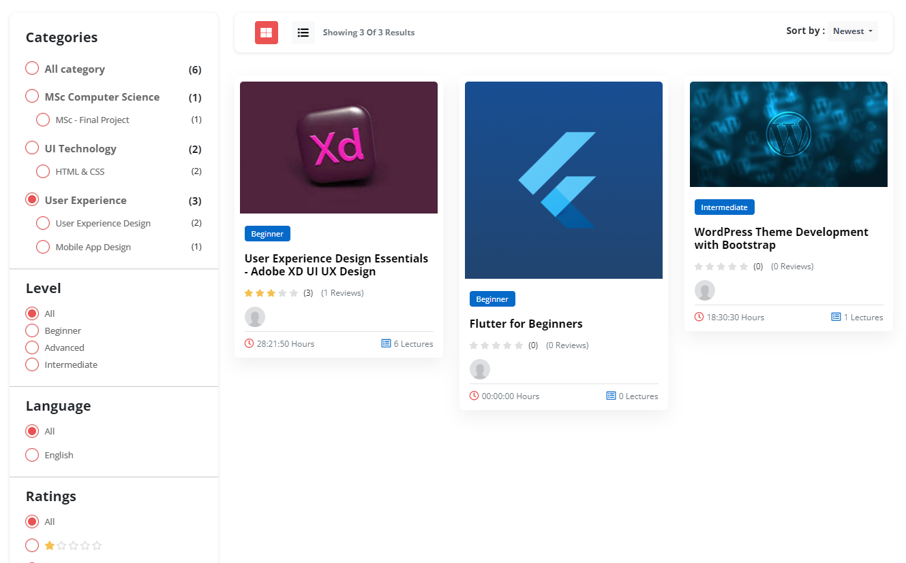

Users can utilise the grid icon up top to view all the courses on the course page in a grid.

**Manage Admin:**

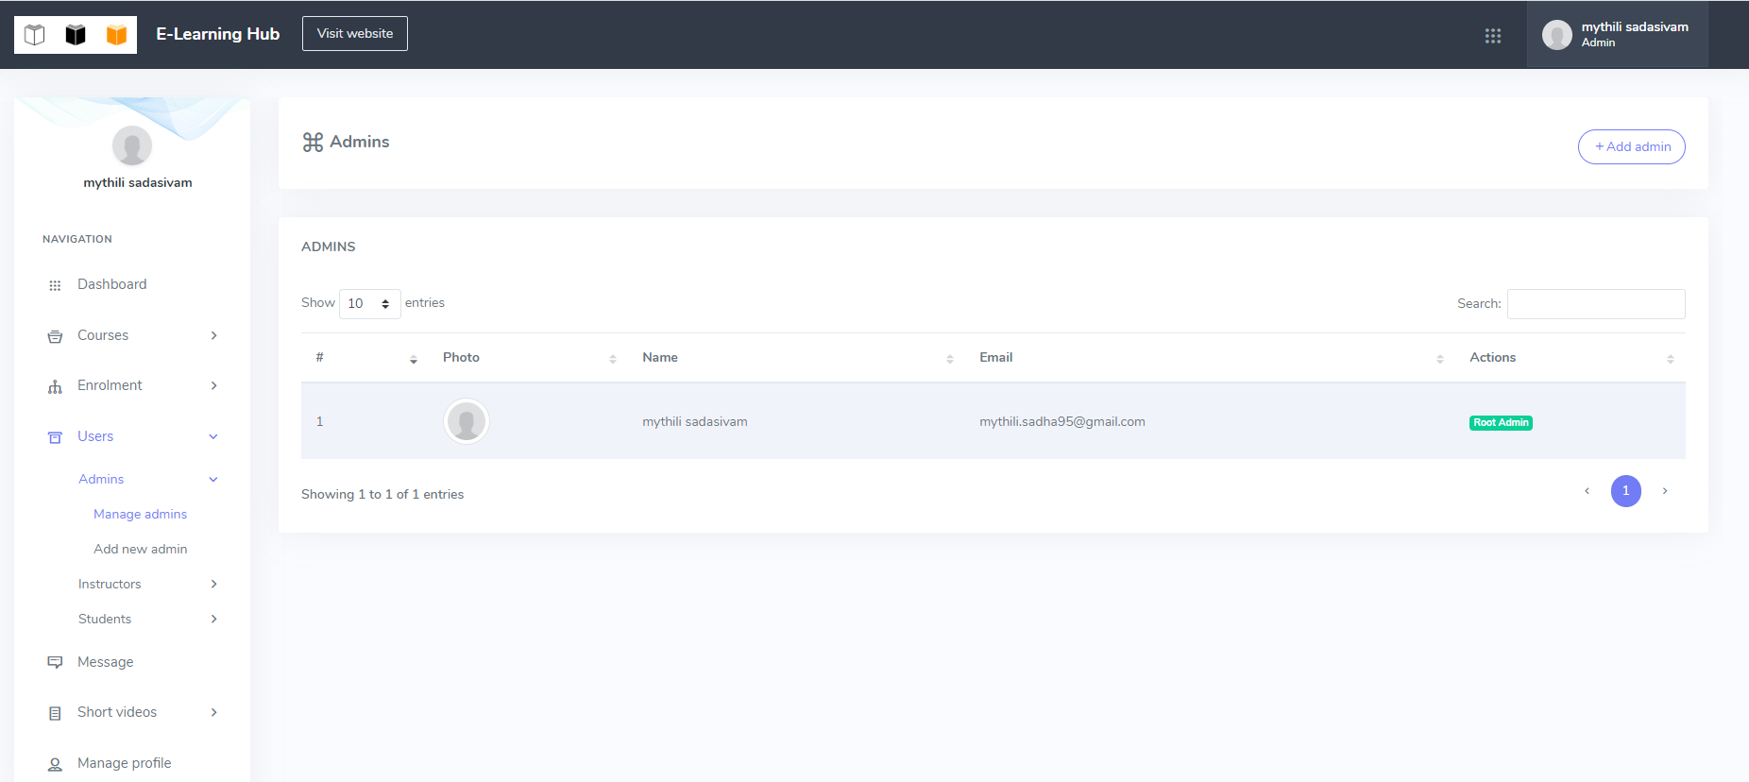

In the e-learning platform, a root admin can control other administrators. These can be given permissions by root admin.

**Add new Admin:**

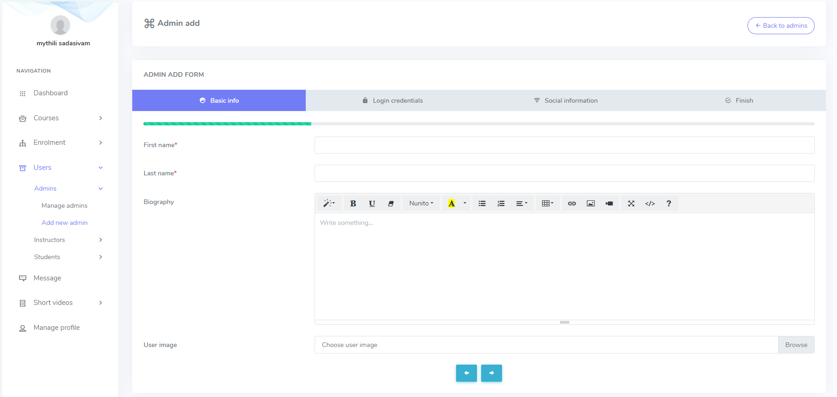

Many other admins may be created by the root admin. They are assistant admins.

**Manage instructors:**

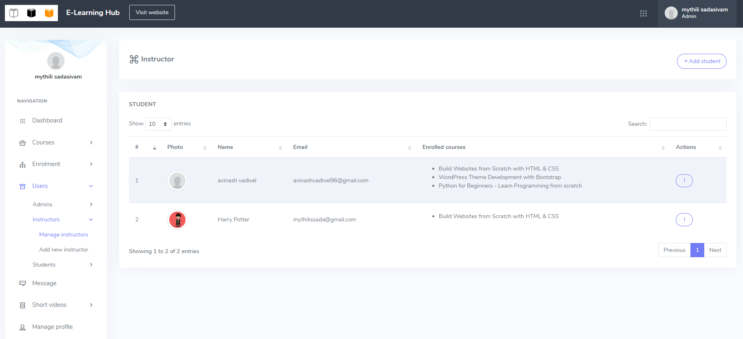

All of the instructors are under the administrator's supervision and may be fired.

**Add new instructor:**

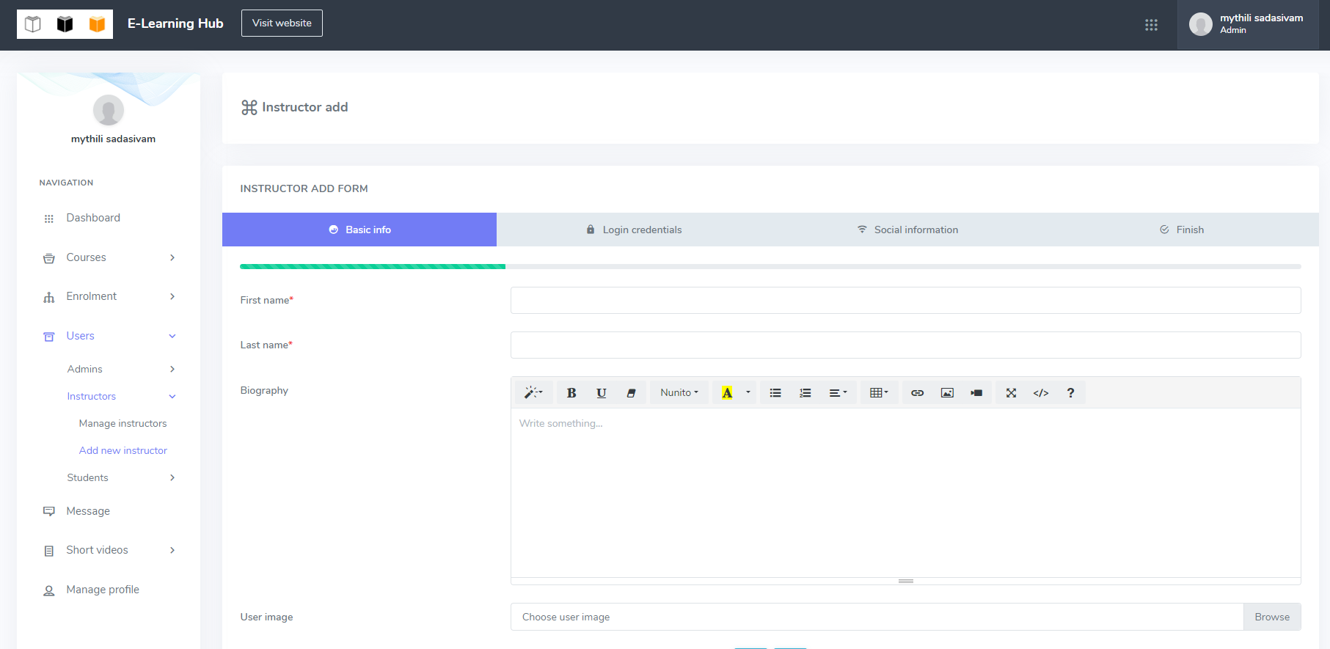

Through the e-learning hub, the administrator can add a new instructor.

**Manage students:**

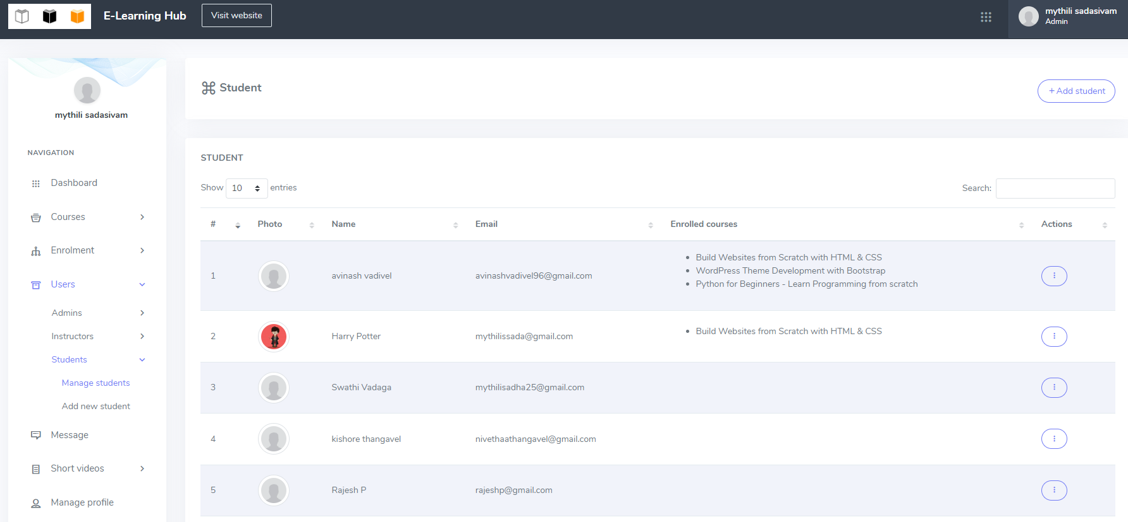

The list of enrolled students is accessible to the administration.

**Add new student:**

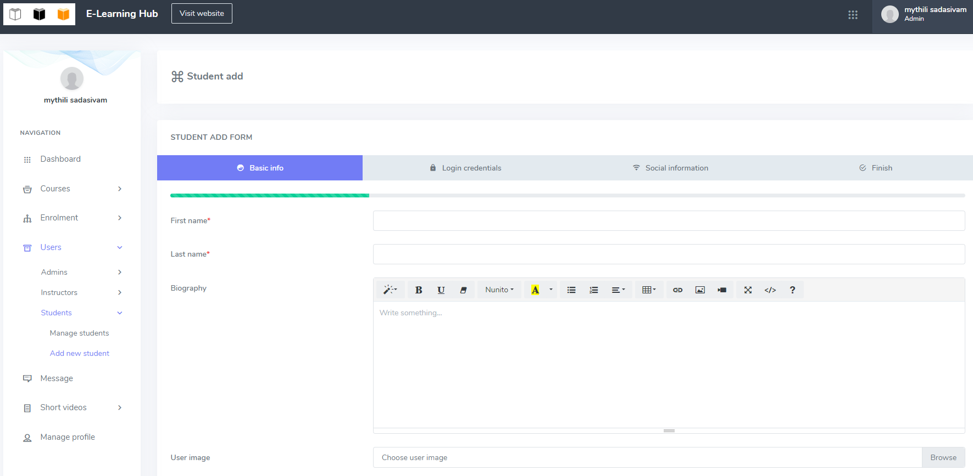

New students may be created by the admin.

**Private message:**

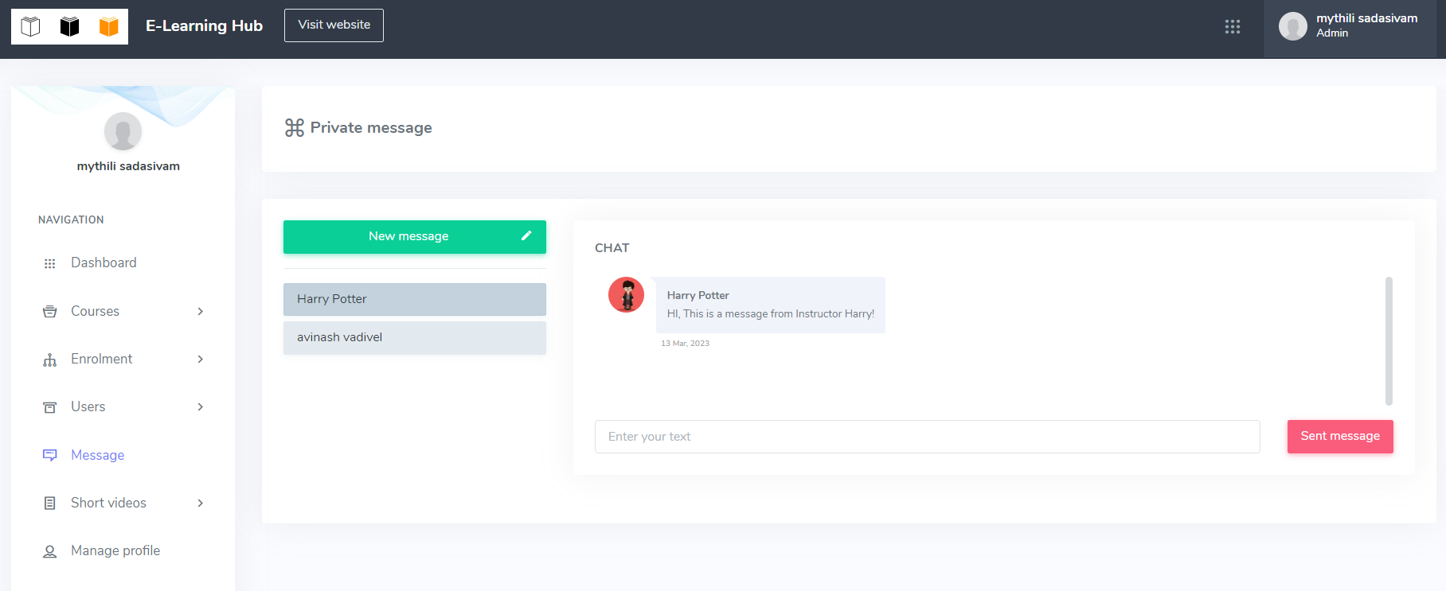

Using the internal messaging platform of the e-learning hub, administrators can communicate with all students and teachers.

**Info of Course**:

Here, course details must be provided by the course author. So that, the students would have a better understanding of the course. Here, the course designer can provide the FAQs, prerequisites, and outcomes.

The following steps can be used by the course creator to add the FAQs:

* Choose the option for course management.
* Click on the "Info" link.
* Expand the "Course FAQ" section to include common queries and responses.
* Use the "+" and "-" buttons to add and remove FAQs, respectively.

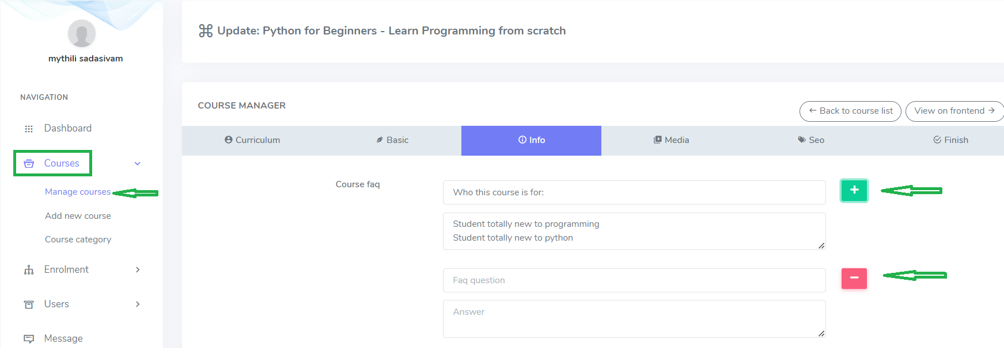

If there are any prerequisites for the course, the instructor can provide them here. Here, the instructor may offer as much as is necessary for the course. Use the "+" button to add more prerequisites. Moreover, instructor can eliminate a course prerequisite by selecting the "-" button.

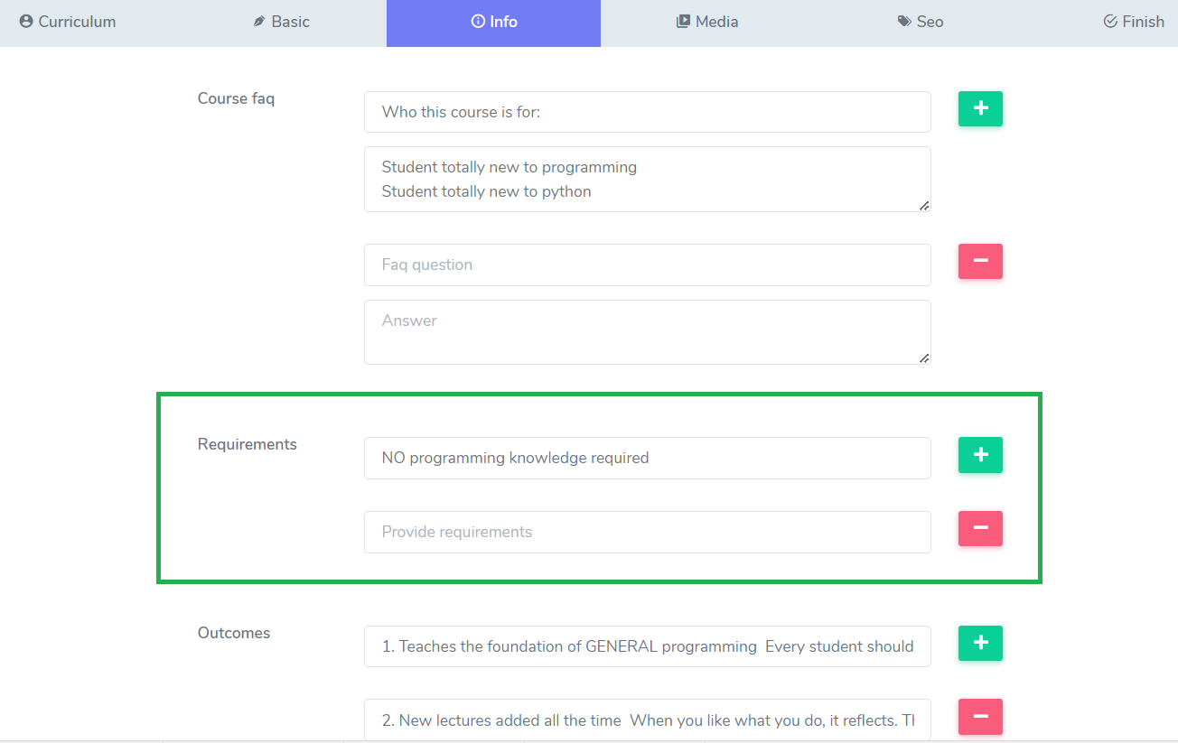

The instructor must record the course outcome on this form. Several outcomes may be added by the instructor. The "+" button must be used by the instructor to add extra criteria. Instructor can also eliminate a result from the course by clicking the "-" button.

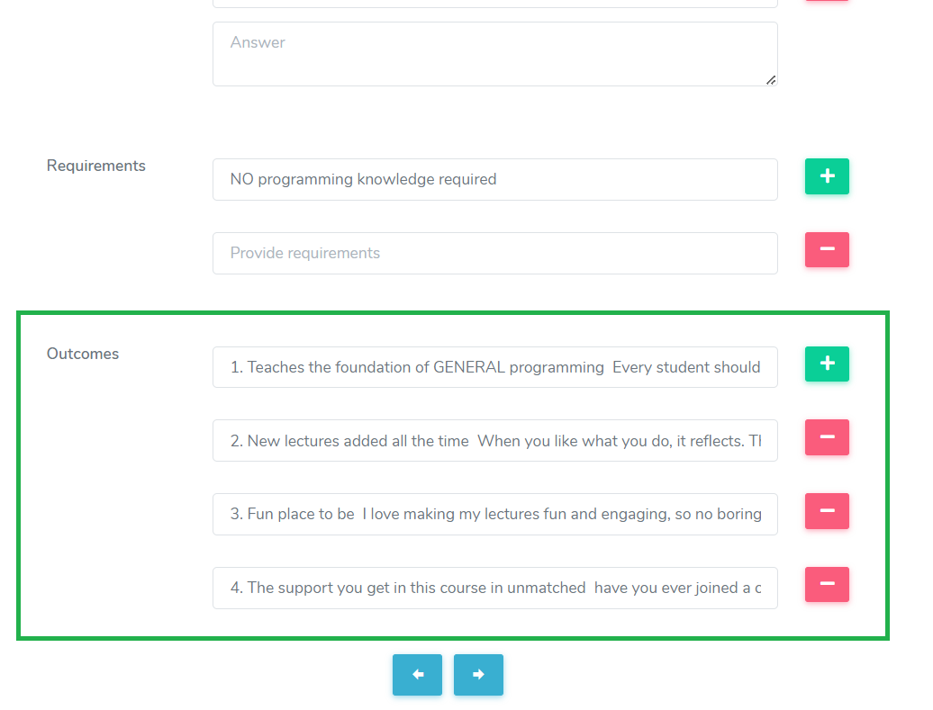

After completing all forms for adding a course, click the "Submit" button.

**Additional Lesson Fomats:**

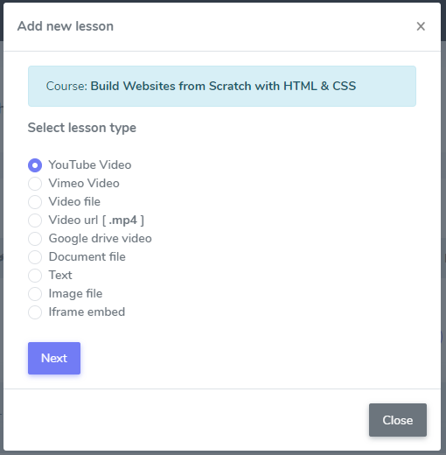

**Vimeo**

The following details must be given by the instructor in order to add a Vimeo video lesson:

* Give the new lesson a title.
* Choose a subsection.
* Provide a video URL.
* Manually add the video duration.
* Describe the lesson in brief.
* Click "Add lesson" to include a fresh Vimeo video lesson.

**Video clip**

The following information must be provided by the instructor before adding a video file lesson:

* Give the new lesson a title.
* Decide which course unit to take.
* Include the system video file.
* Manually set the video's runtime.
* Upload the captions file for the video.
* Describe the lesson in brief.
* To add a new video file lesson, select the "Add lesson" button.

**Video URL (MP4)**

The following details must be provided by the instructor before adding an MP4 lesson:

* Give the new lesson a title.
* Decide which course unit to take.
* Add the video URL.
* Specify the video's runtime.
* Upload an image
* Upload the captions file for the video.
* Describe the lesson in brief.
* To add an MP4 lesson, click the "Add lesson" button.

**Video on Google Drive**

The following details must be provided by the instructor before adding a Google Drive video lesson:

* Give the new lesson a title.
* Decide which course unit to take.
* Add the video URL.
* Choose a manual video duration.
* Describe the lesson in brief.
* Click the "Add lesson" option to include a video lesson from Google Drive.

**File of documents**

The following details must be added by the instructor before adding a document file lesson:

* Give the new lesson a title.
* Decide which course unit to take.
* Choose the type of document. (The user may select between a text, PDF, or document file.)
* Include an annexe.
* Describe the lesson in brief.
* To add a lesson involving a document file, click the "Add lesson" button.

**Text**

Instructor must enter the following details, instructor, in order to add a text file lesson:

* Give the new lesson a title.
* Decide which course unit to take.
* Describe the lesson in brief.
* To add a text file lesson, click the "Add lesson" button.

**Picture file**

The following details must be included by the instructor before adding an image file lesson: • Give the new lesson a title.

* Decide which course unit to take.
* Add a file as an attachment.
* Describe the lesson in brief.
* To add an image file lesson, click the "Add lesson" button.

**Embed Iframe**

The following details must be given by the instructor in order to add an image file lesson:

* Give the new lesson a title.
* Decide which course unit to take.
* Include the iframe source.
* Describe the lesson in brief.
* To add an iframe embed lesson, click the "Add lesson" button.

**Instructor panel:**

The following actions must be taken by the teacher in order to create a new lesson via the instructor panel:

* Access the teacher panel by logging in.
* Choose "Course manager" from the menu on the left.
* From the "Action" menu, click the "Edit this course" button.
* From the "Curriculum" form, select the "Add lesson" button.

**Additional Quiz Question Types:**

**MCQ:**

This question type allows to present questions with a variety of options and responses. Here, students may select from a variety of options. The steps listed below can be used to construct multiple choice questions:

* From the course syllabus, choose quiz.
* Choose the icon for the "Question box."

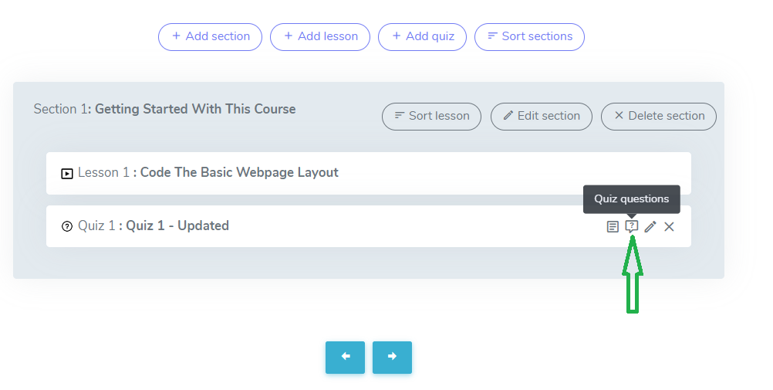

* Choose "Add new question" from the menu.

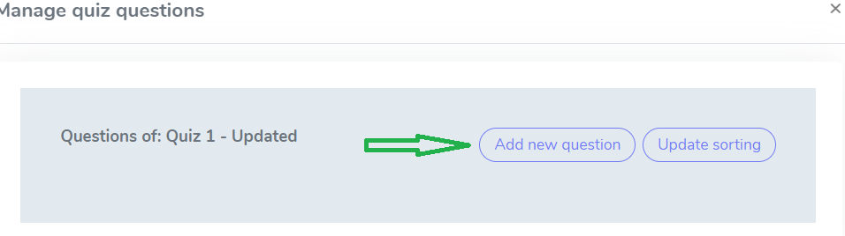

* Type the query in the space provided. (User can add tables, links, videos, and images; alter the font style, theme, bold, underlining, and colour.)

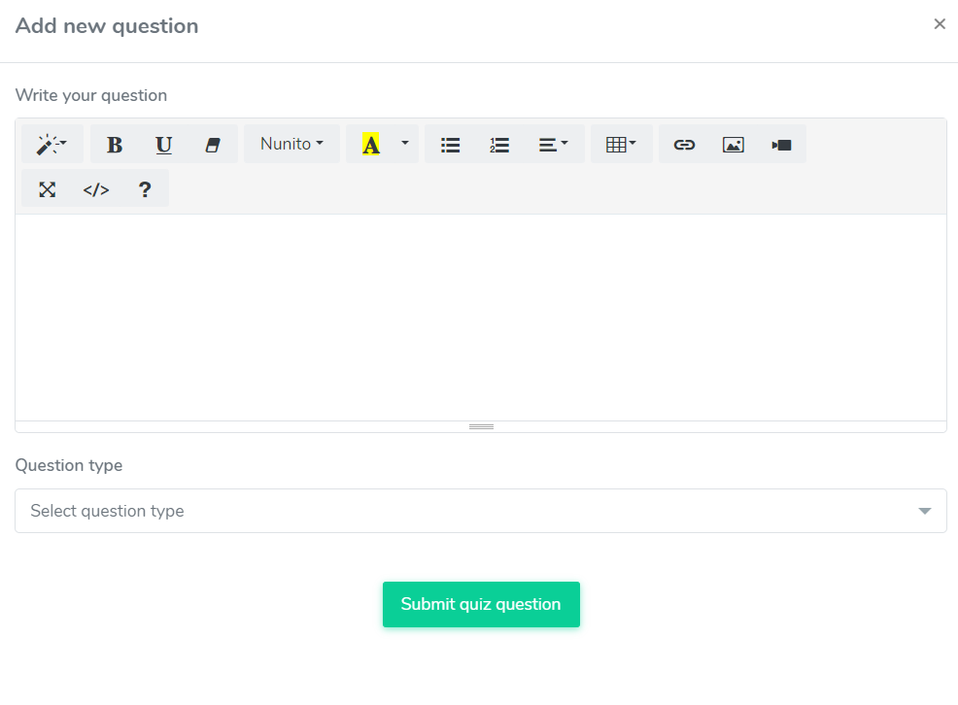

* Choose "Select question type" from the menu.
* Choose "Multiple choice" from the menu.

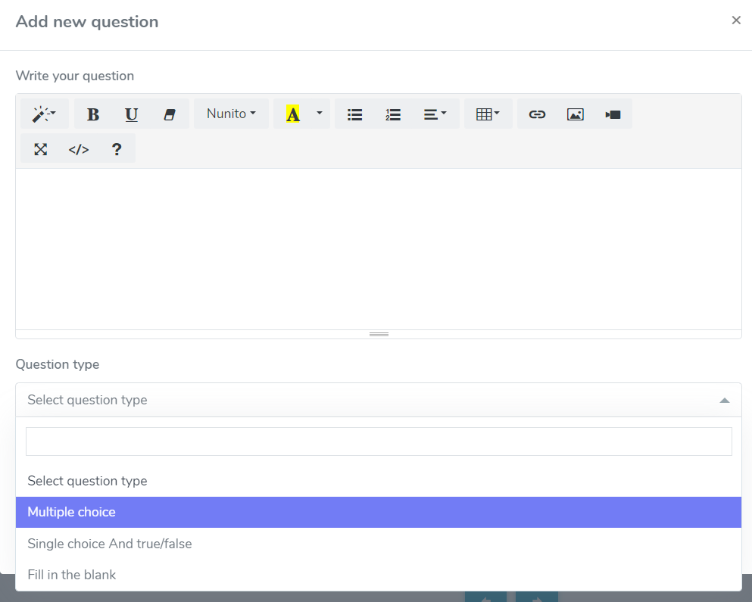

* Specify the number of choices.
* Add the name of the option.
* If the given answers are accurate, click the bar. (The course instructor may add a number of accurate responses.)
* Click the button labelled "Submit quiz question".

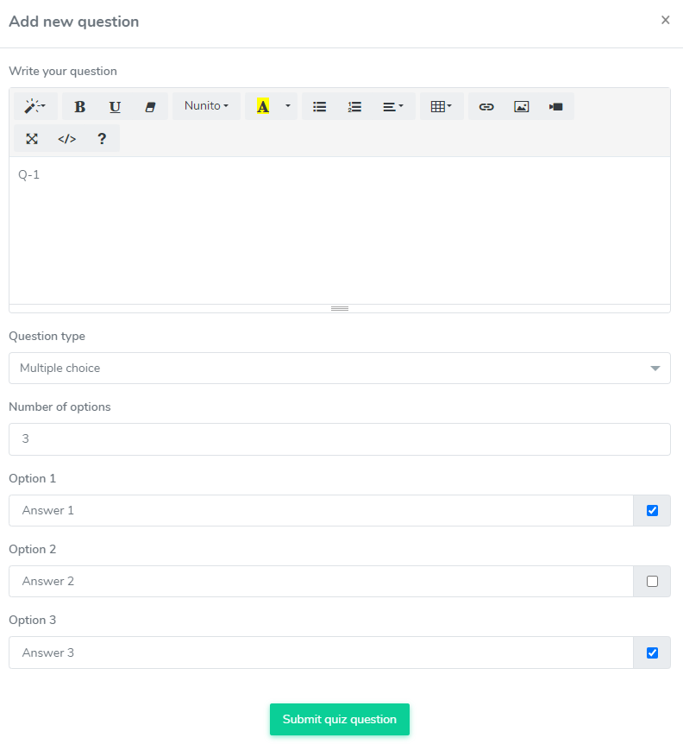

The multiple-choice question may be updated at any moment by the course teacher. To do this, take the following actions:

* From the course syllabus, choose the quiz.
* Choose the icon for the "Question box."



* Decide on the question.
* Choose the "Edit" button.

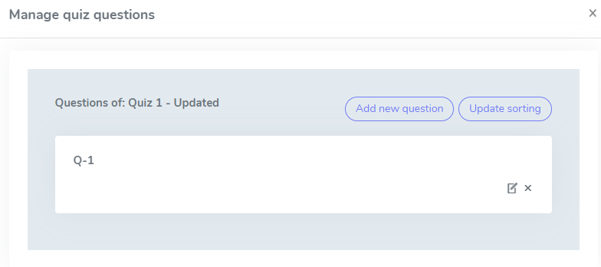

* Update the necessary data.
* Click the button labelled "Submit quiz question".

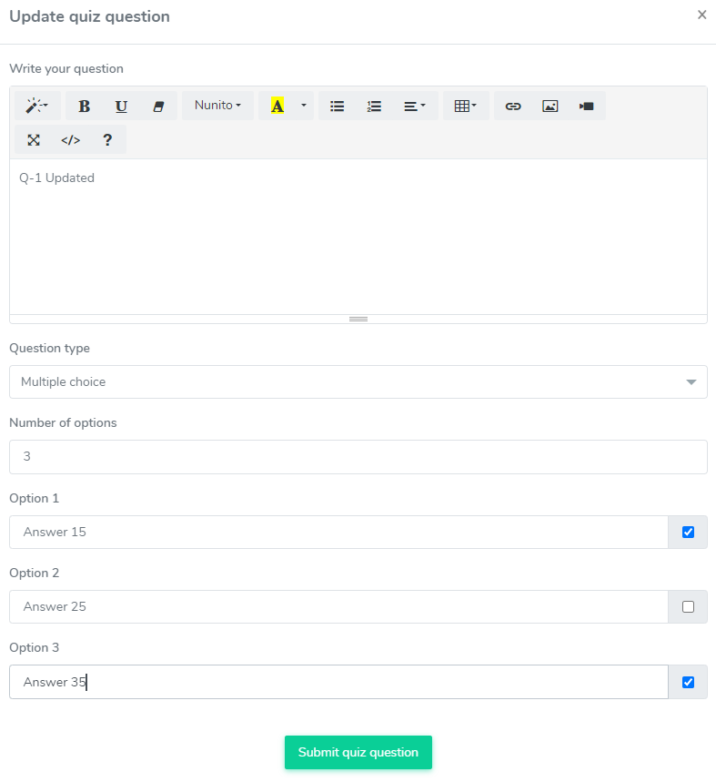

The following procedures can be used by the course teacher to remove a multiple-choice question:

* From the course syllabus, choose the quiz.
* Choose the icon for the "Question box."
* Decide on the inquiry.
* Choose the "X" button.

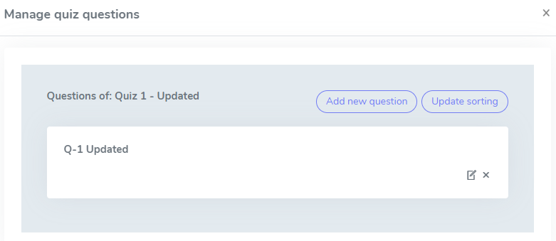

* To confirm, click the "Continue" button.

Questions can also be sorted by dragging and dropping by the course teacher. Then select "Update sorting" from the menu.

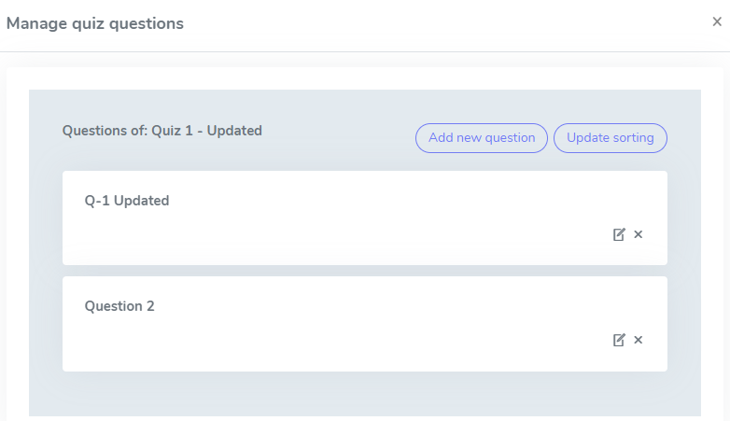

**Single-choice question/True-False:**

With this question type, the course instructor may offer questions that have just one right response. Single-choice questions may also be marked as true or false by the course teacher. Create two options: one for "True" and one for "False." Students must choose just one response. The following procedures should be followed to construct the single-choice question:

* From the course syllabus, choose the quiz.
* Choose the icon for the "Question box."
* Choose "Add new question" from the menu.
* Enter the query in the space provided. (The instructor of the course has the ability to alter the font style, theme, bold, underline, colour, add tables, links, videos, and images.)
* Choose "Pick question type" from the menu.
* Choose "Single choice" from the menu.
* Specify the number of choices.
* Add the name of the option.
* If the given answers are accurate, click the bar. (The course instructor may select the appropriate response.)
* Click the button labelled "Submit quiz question.".

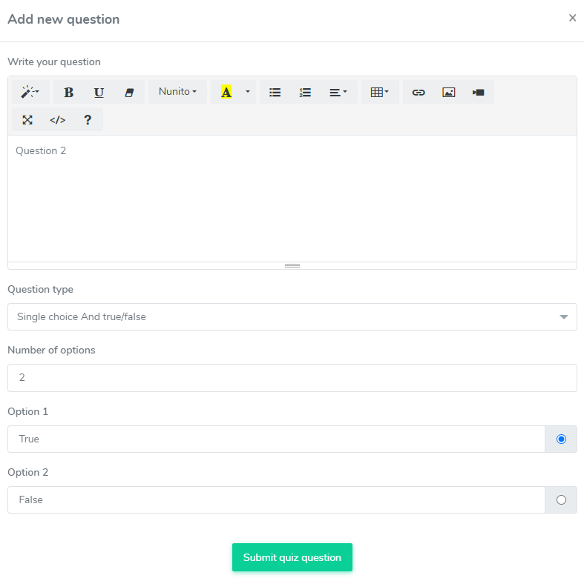

The single-choice and true-false questions are subject to change at any time by the course teacher. To do this, take the following actions:

* Choose a test from the course syllabus.
* Choose the icon for the "Question box."
* Decide on the inquiry.
* Choose the "Edit" button.
* Update the necessary data.
* Click the button labelled "Submit quiz question."

The following procedures can be used by the course teacher to remove a single-choice question:

* From the course syllabus, choose the quiz.
* Choose the icon for the "Question box."
* Decide on the inquiry.
* Choose the "X" button.

To confirm, click the "Continue" button.

**Instructor Approval**

Students have the opportunity to become instructors on an e-learning platform. To become a teacher, a student must obtain permission. For this, students must follow these steps:

* Sign in as a student.
* On the welcome screen, choose "Instructor."
* From the left menu, select "Become an instructor".

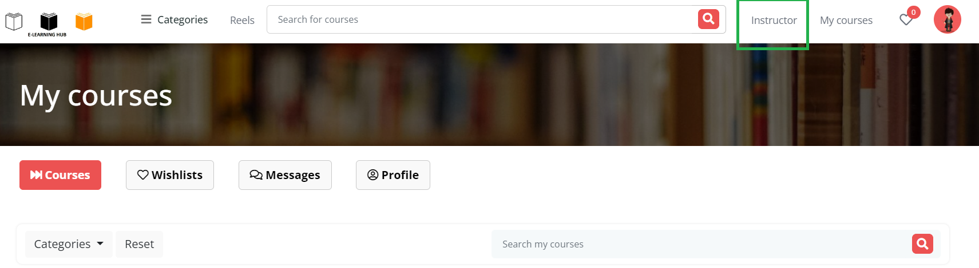

Now, fill in some critical information. For instance: Name, email address, and a brief message are required.

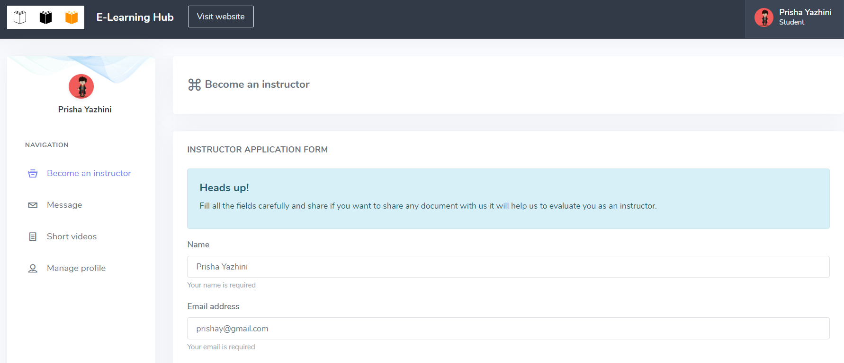

Choose the "Apply" button to save the data.

Only the administrator can grant the request once the student has asked the instructor for authorization. The procedures listed below must be taken by the admin in order to accept the request:

* Access the admin panel.
* From the menu on the left, choose "User".
* From the submenu, select "Instructors."
* Choose "application" from the menu.

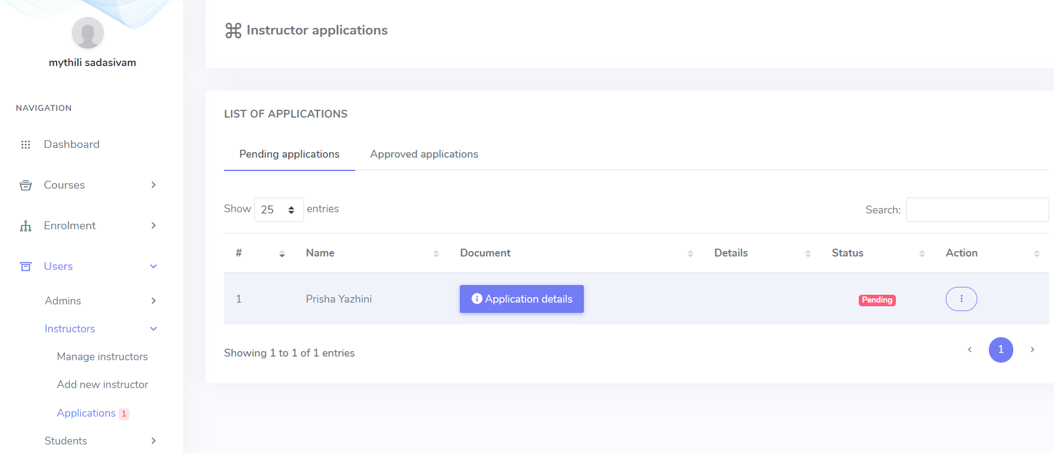

An administrator can access the following information in this panel: applicant names, request status, approved applications, and the ability to approve and remove.

The request can be approved here, and an instructor will be added to the application form.

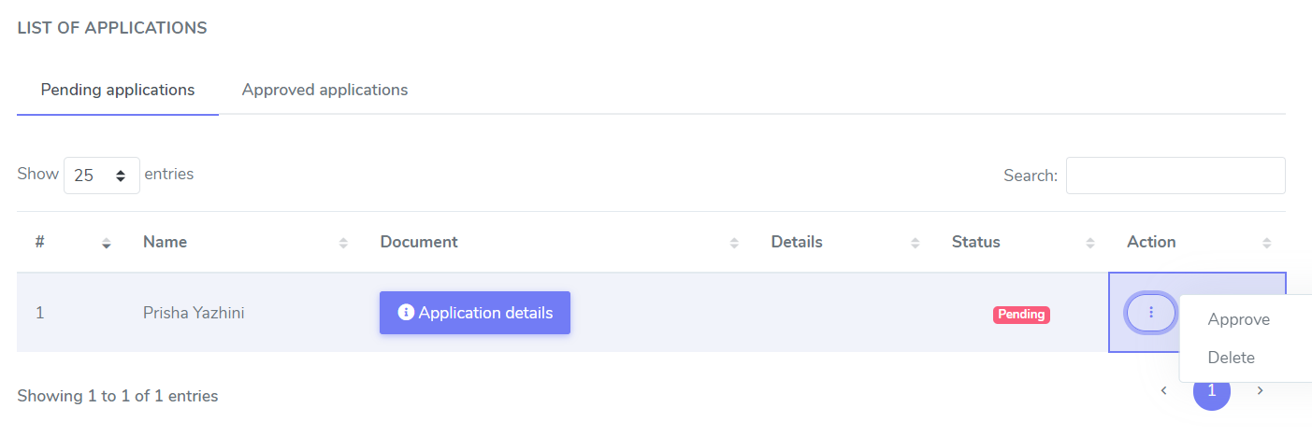

**Taking care of my profile**

One may manage their personal information and update or change their password whenever they like with a video subscription service.

**Ways to make changes to personal data:**

One can manage their personal information by following the instructions below:

* Open the application for the video subscription service.
* On the right side, choose profile picture.
* Choose "My profile" from the menu.
* Update any necessary information.
* Choose "Save" from the menu**.**

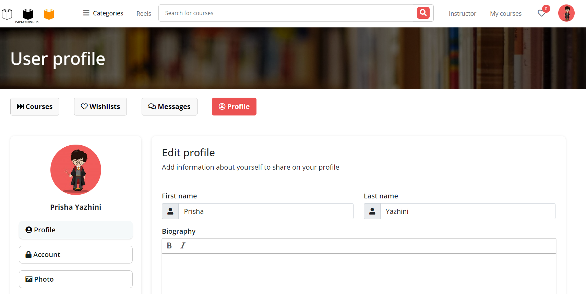

**How to change/update password:**

One may quickly alter their passwords to increase the security of their video hosting server. They can do this by taking the actions listed below:

* Open the application for the video subscription service.
* On the right side, choose profile picture.
* Choose "Change password" from the menu.
* Provide new password, then give it to confirm.
* Choose "Save" from the menu.

